General Surgery
Frimley Park and Wexham Park Hospitals

Anti-Reflux Surgery

Background

Sometimes patients with gastro-oesophageal reflux disease benefit from surgery to treat their symptoms. Laparoscopic fundoplication is the gold standard for anti-reflux surgery and involves wrapping the top part of the stomach (called the fundus) around the lower oesophagus (food pipe) to create a new valve. If there is a hiatus hernia this will be repaired too. This is a keyhole day-case procedure.

Once seen in clinic, the Upper GI surgeon can arrange an OGD (camera into the stomach in Endoscopy), an X-Ray test called a barium swallow and further specialist tests called GI physiology studies to investigate if surgery is the right treatment for your symptoms. Even if you have already had an OGD, it may need repeating for surgical assessment.

Referral Criteria

Anti-reflux surgery is suitable for patients with:
- Refractory reflux despite maximal medical treatment
- Patients with daily reflux on medication who would prefer to have surgery
- Patients with complications of reflux, e.g., ulcers or strictures
- Patients with “volume” reflux (regurgitation)
- BMI <35

What can I expect on the day of surgery?

You will receive a letter with instructions about the date and place of your surgery and starving instructions before surgery.

When you arrive to the ward, you will be admitted by the nursing team before you meet the surgeon and anaesthetist. The surgeon will go through the risks and benefits of surgery with you and answer any questions you have before you sign the consent form. You have the right to withdraw consent at any time.

Risks, complications as well as alternative treatments will have been explained to you in detail in clinic before surgery is booked so the consent process on the day is more of a recap and a chance to ask any additional questions you and your family may have thought of after the clinic consultation.

The anaesthetic doctor will go through risks of anaesthesia and talk you through the process of going to sleep and what to expect when you wake up.

What are the risks of a Laparoscopic Fundoplication?

- Infection including that of the lung, blood, abdomen and urine
- Deep vein thrombosis and pulmonary embolism
- Bleeding requiring a transfusion or emergency surgery
- Injury to blood vessels, nerves, abdominal organs or the lining of the lung (pleura)
- Post-operative perforation is a serious complication which can lead to further surgery, a prolonged hospital stay, admission to intensive care, invasive lines and drains.
- Conversion from keyhole to open surgery -this results in a longer hospital stay
- Drain insertion
- Prolonged difficulty swallowing 5% – difficulty swallowing normal foods that does not improve within 6 months of surgery may need further investigation and treatment.
- Incomplete control of reflux or recurrence of reflux – this is usually treated with anti-reflux medication and in some cases revisional surgery.
- Gas-Bloating or irritable bowel symptoms
- Hernia near one of the cuts (port site hernia)
- Death – any surgery or invasive procedure carries a risk of death. The risk from a fundoplication varies from 1:1000 to 1:100 depending on an individual’s health.

What happens after surgery?

You will be woken up and taken to recovery for a few hours before moving back to the ward.

The nurses will check your vitals regularly and dispense medications including pain killers. You are expected to get out of bed as soon as possible as the surgery is keyhole. You will be asked to drink water in recovery.

You will be advised to stick to the Hiatal Surgery Post-Operative Diet. Most people can resume a normal diet 4-6 weeks after surgery. You will be handed a detailed FHFT Hiatal Surgery Post-Operative Diet leaflet before discharge, along with your discharge summary and a pack of post-operative medications to keep you comfortable for the first few weeks.

How long will I be in the hospital after my fundoplication operation?

Laparoscopic fundoplication is a day case procedure in most cases; some patients will need to stay in overnight. When the Nurses are satisfied that you have met the discharge criteria, you will be allowed to go home. Day Surgery is open until 10 pm, so there is plenty of time for you to get ready!

When can I resume normal activities?

You will be able to resume normal activities, including a normal diet 6 to 8 weeks after surgery. It is recommended that you avoid exercise involving heavy lifting for a longer period in order to protect the new wrap and/or hiatus hernia repair.

What about driving?

You cannot drive until you are able to perform an emergency stop safely without pain; this is usually at least 10 days from surgery.

Will there be further follow up after the surgery?

An out-patient clinic appointment is made for approximately 6 weeks after surgery for a check-up with your surgeon. This can be done in person in clinic or over the phone.

I heard surgery might be done with the robot; what is the difference?

Your surgeon may perform your surgery robotically; this is a different key hole surgery approach and has no bearing on outcome.

Reference

- https://cks.nice.org.uk/topics/dyspepsia-proven-gord/management/dyspepsia-proven-gord/

If you are experiencing any of the following symptoms, please contact your surgical team

- Unable to eat or drink.
- Severe pain
- Fever
- Feeling unwell
- Wound problems

Contact Information

- If your operation was at Wexham Park Hospital

Call 07468 354436 available Monday to Friday 9am to 5pm

07826 921319 available 10pm to 7am

- If your operation was at Frimley Park Hospital

Call 07990 528061 available 24 hours

- If you cannot get in contact, please call 111

- If you feel seriously unwell, call 999 or go to the nearest Emergency Department

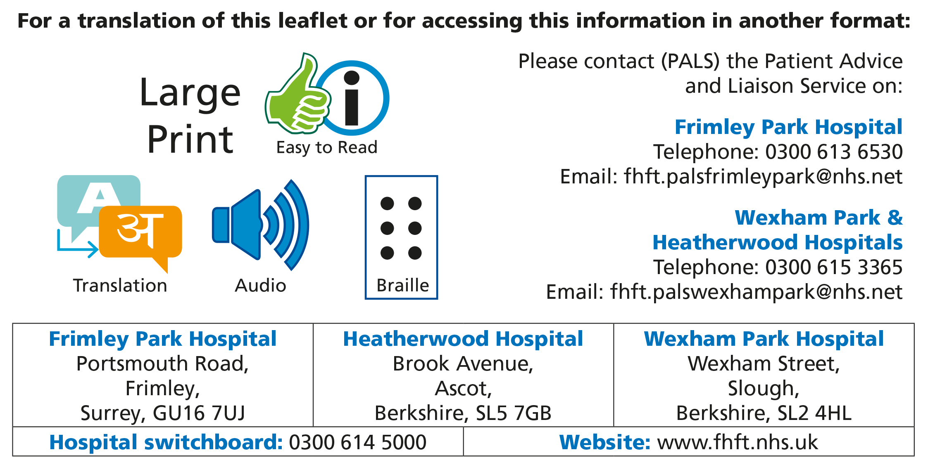

Title of Leaflet | Anti-Reflux Surgery
Author | J El Kafsi, I Wilson, Consultant Upper GI Surgeons  Department of General Surgery
Ref. No | Y/009/5 | Issue Date | April 2024 | Review Date | April 2026

Legal Notice
Please remember that this leaflet is intended as general information only. We aim to make the information as up to date and accurate as possible. Please therefore always check specific advice or any concerns you may have with your doctor.

