This information leaflet explains why you have been referred to hospital, what it means and what you need to do.
Why have I been referred urgently to hospital?

You have been referred urgently because your health practitioner feels you might be at risk of cancer and your symptoms need urgent further investigation. You can expect to be seen quickly to find out what is wrong with you. The appointment is very important.

Does this mean I have cancer?

There are many conditions that your symptoms could be linked to, including the possibility of cancer. Most people who are referred urgently do not have cancer.
If cancer is diagnosed, an early diagnosis means treatment is likely to be more effective. This is why it is important that you are seen early. You should be given a diagnosis within four weeks.

Attending your appointment

Please make every effort to attend the first appointment you are given, which may be via telephone, video or in person. However, if you cannot make the appointment or test you are given, please contact the hospital as soon as possible, so an alternative can be arranged.

What does your GP Practice need to know?

Make sure your practice has an up-to-date home address and correct telephone number – including a mobile number – for you as the hospital may contact you via telephone to arrange your appointment.
You may be invited to attend hospital for some tests or investigations. This could be any time from the day after your referral is sent to the hospital by your health practitioner.
Please tell your GP practice if you are unable to manage a telephone call or need an interpreter, including sign language, and they will inform the hospital.
Please inform your GP practice of any dates you are unable to attend appointments within the next four weeks.

What will happen next?

You will be contacted to discuss the next steps; this could be via phone or letter. If you require any tests, you may be sent information with more details.
How do I get an appointment / test?

You will be contacted by the hospital about your appointment.
If you cannot drive or arrange your own transport, or public transport is limited, ask the receptionist at your doctors if you can use the patient ambulance transport service.
If you have not been contacted by the hospital for an appointment within 14 days please contact the hospital
Frimley Park Hospital – Please phone between Monday and Friday 8.30am to 4.30pm - Main outpatient appointment centre: 0300 613 4201
Wexham Park Hospital – Please phone between Monday and Friday 8.30am to 4.30pm - Main outpatient appointment centre: 0300 614 7919

This is understandably going to be a worrying time for you. There is help and support available should you have any questions or concerns please see below.

www.macmillan.org.uk/information-and-support

https://www.cancerresearchuk.org/cancer-symptoms/what-is-an-urgent-referral

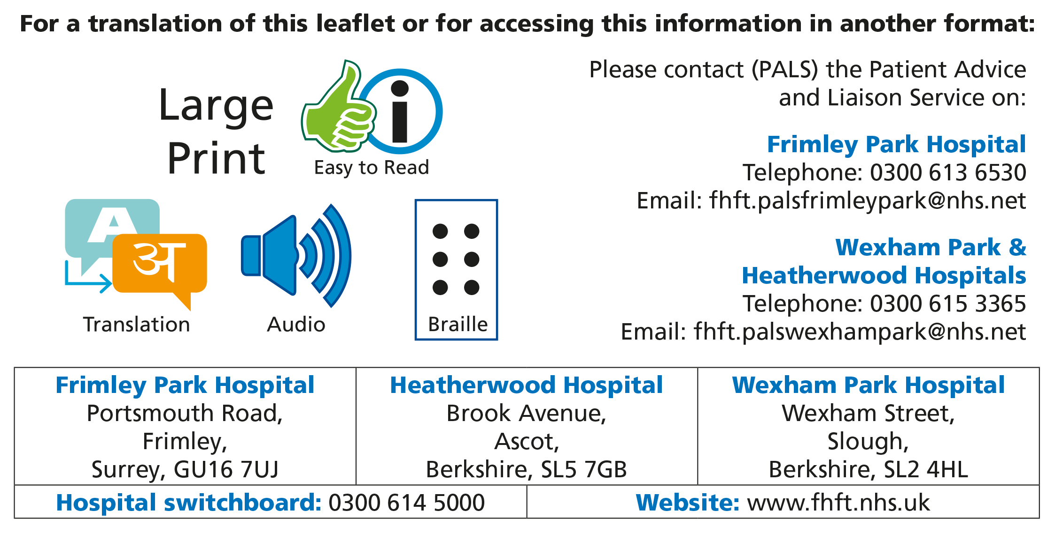
Title of Leaflet | Patient Information Urgent Suspected Cancer
Author | Chris Lima |  | Department | Cancer Services
Ref. No |  | Issue Date | 01/07/2024 | Review Date | 3/06/2026

Legal Notice - Please remember that this leaflet is intended as general information only. We aim to make the information as up to date and accurate as possible. Please therefore always check specific advice or any concerns you may have with your doctor.

