

Trauma and OrthopaedicsDepartment
Frimley Park and Wexham Park Hospital

Virtual Fracture Clinic

We have given you this leaflet because you have been referred to the virtual fracture clinic.

The team will review your referral information and investigations to assess your fracture. We will then contact you to tell you the outcome.

Information for patients, relatives
and carers

What is the Virtual Fracture Clinic?
Virtual Fracture Clinic is a new concept and approach to managing patients with a fracture or soft-tissue injury.

Previously, all patients seen within the Emergency Department with a fracture, suspected injury of their bone or soft-tissue injury would be given an appointment to come to the fracture clinic at the hospital.

Why is this better for me?
We now have a better understanding of which fractures can heal without medical intervention and which require specialist orthopaedic input. This will avoid unnecessary attendances where there is no change to treatment.

If you do need to be seen, we can arrange the most appropriate specialist at the required time following your injury.

What will happen now?
The Virtual Fracture clinic team of consultant orthopaedic surgeons and physiotherapists will assess your referral the next working day, and will make a decision on your most suitable treatment plan.
We will then contact you with 1 of 3 options:
- We need to see you in fracture clinic
- We need you to have further investigations before your clinic appointment
- We do not need to see you and your injury can be self-managed – we will send you information leaflets

We will also send a copy of your letter from the virtual fracture clinic to you and your GP.

What if I have any problems?
Whether you are discharged from the emergency department, after virtual fracture clinic, or after attending your appointment, you can always contact us on the virtual fracture clinic hotline. This line is manned between 8am and 4pm Monday to Friday at Frimley and 8.30am and 4pm at Wexham, and we will then arrange for the appropriate person to call you back if need be.

Please see all necessary contact details below.

Contact us

Virtual fracture clinic
Frimley Tel – 07584 330634
Frimley Email - fhft.virtualfractureclinic@nhs.net
Wexham Tel – 07584 558292
Wexham Email – fhft.vfcwph@nhs.net

Available 8am – 4pm Monday to Friday, Frimley and 8.30am – 4pm, Wexham (excluding weekends & bank holidays)

Please leave a message if there is no answer, and we will call you back as soon as possible.

Appointments team
Frimley Tel – 0300 614 7919 ext.1
Wexham Tel – 0300 614 7919 ext.1

In an emergency

- Speak to your GP
- Call 111
- Go to the emergency department

We will contact you after you attend ED or your GP, so please make sure we have your current contact details, including at least one phone number and an email address if possible. If we are unable to contact you, we will leave a short message asking you to get in touch with the Virtual Fracture Clinic.

If you do not hear from us within 1 week of your attendance in ED or GP surgery, please call the Virtual Fracture Clinic.

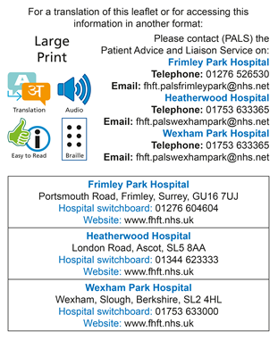
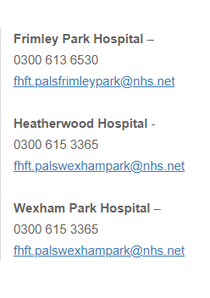

Title of Leaflet | Virtual Fracture Clinic
Author | Service manager, Orthopaedics |  | Department | Trauma & Orthopaedics
Ref. No | N/054/1 | Issue Date | August 2024 | Review Date | August 2026

Legal Notice

Please remember that this leaflet is intended as general information only. We aim to make the information as up to date and accurate as possible. Please therefore always check specific advice or any concerns you may have with your doctor.

